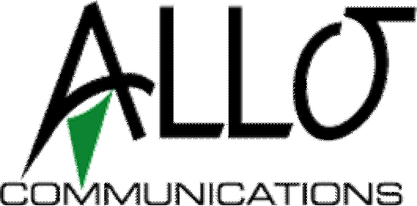

Autopay Request Form
Name on Account: Service Address: Account #:
Phone #:
Email:

ACH Bank Debit Authorization

I hereby authorize ALLO Communications to automatically process my monthly service billing by way of debit entry to the specified bank account below, until notification to the contrary is given. I understand that the automatic debit will be processed on the 1st or 15th of each month for the full amount due at the time of processing.

Bank Account Type: (Please check one) Checking Savings

Bank Name:
Bank Phone #

Routing Number: Account Number: Name on Account:

Authorized Signature:
Date

Please include a voided check from your checking account.

Please submit form:
- Mail with your next bill payment
- Scan and e-mail to: info@allophone.net
- Return to your local ALLO store:

1450 10th St 1710 E 20th St 100 N Spruce St 702 E Francis
Gering, NE Scottsbluff, NE Ogallala, NE North Platte, NE

Customer Service Contact Numbers

 | Business | Residential
SB/Gering: | 308-633-5000 | 308-633-5050
North Platte: | 308-532-7300 | 308-532-1400
Ogallala: | 308-284-7500 | 308-284-7550
Bridgeport: | 308-262-7500 | 308-262-7550
Toll Free — 866-481-2556

